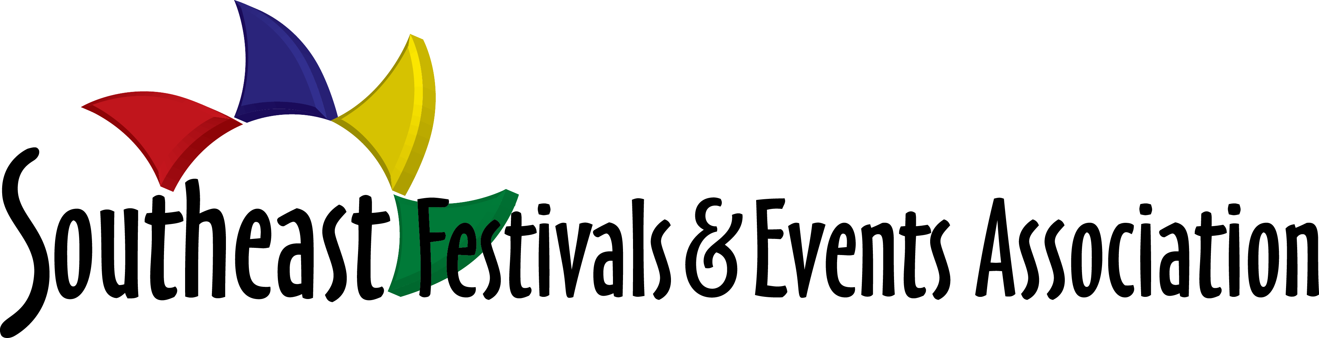

Trade Show Information
Dollywood DreamMore Resort, Pigeon Forge, TN

The Southeast Festivals and Events Conference is designed for event professionals. It is an excellent opportunity to promote your products and services and to develop and strengthen personal relationships. Included with your booth registration is access to all functions: educational sessions and panel discussions, meals and social events, Kaleidoscope Awards Banquet and Reception, networking opportunities and nightly hospitality. Registration is required for all staff and booth workers. Please keep in mind that networking is a powerful tool so take advantage of time outside the Trade Show to learn more about your existing and potential clients.

Important Deadlines & Fees
Early Bird Registration Discount: until December 14, 2018
Final Deadline to Apply: February 8, 2019 – Please note that the trade show could sell-out prior to this date
Hotel room rate: $109.00 + tax
Parking: Complimentary

Tradeshow Fees | Member | Non-Member
Before December 14 | $460.00 | $560.00
After December 14 | $560.00 | $660.00
Additional attendee | $235.00 | $285.00
Additional 8 ft. table  Elec | $35.00 | $35.00
Electrical | $25.00 | $25.00

Booth details
Booths are approx. 10’ wide and 10’ deep and consist of an 6’ skirted table & 2 chairs. Table top displays are encouraged.

Hotel Reservation
A room block has been reserved for the conference and the nightly rate is guaranteed until February 1, 2019. The nightly rate for single or double occupancy is $109.00/night plus tax.
To make reservations: go online to www.southeastfestivals.org conference page for a link to hotel reservations.

Shipping
Embassy Suites, Murfreesboro, TN is the official hotel for the SFEA Conference. Packages will be accepted no
earlier than 48 hours prior to your arrival. Please ship to: Dollywood’s DreamMore Resort & Spa, c/o Southeast Festivals & Events Association Conference, 2525 DreamMore Way, Pigeon Forge, TN 37863, HOLD FOR ARRIVAL DATE OF Sunday, February 24, 2019. All shipping charges are at the expense of the exhibitor.

Program Ad
Exhibitors are invited to place an ad in the conference program. Program ad rates are as follows:

Full page $300
½ page $150
¼ page $75

Email program ads to: sfea@southeastfestivals.org by December 30, 2018.

Membership
Membership is not required, but highly recommended and will provide you substantial savings on your conference registration. To learn more, go to www.southeastfestivals.org.

Sponsorship
Unique opportunities for additional exposure are available. Please check the website for sponsorship information or to create a package tailor-made for your marketing objective, contact SFEA at sfea@southeastfestivals.org.

Pre-Conference Dine-Around
Come early on February 24 to join other attendees for the dine around night out in Murfreesboro! Dinner is not included in conference pricing and therefore, “on your own,” but we all dine in groups so it is a great time to get a jump-start on developing some future business relationships.

A Tradeshow Exhibitor receives the following benefits:
- Company listed on the Exhibitor Contact Sheet.
- Company listed in the program
- Attendance to Educational Sessions
- Attendance to Monday Night’s Silent Auction and Cocktail Reception.
- Attendance to Monday Night’s Kaleidoscope Awards program and dinner
- Attendance to the Tuesday Night Dinner Function
- Attendance to the General and Closing Sessions
- The opportunity to network with industry professionals, representing Festivals & Events in the Southeast.

Tradeshow Schedule/Set-Up Details: To be announced.

Please Remember: The Member/Non-Member Booth Rate includes meals, socials, networking functions, educational sessions, & nightly hospitality for one (1) person.

